Energy Balance User Manual

Table of Contents

Introduction: 2

System Requirements: 2

Installation: 2

User Interface Overview: 11

Pre-Loaded Data and how to replace/update data 13

Troubleshooting: 14

Frequently Asked Questions: 14

# Introduction:

The Energy Balance User Manual provides instructions and guidance on how to effectively utilize the Energy Balance solution developed for the WIL project for CAEEPR. It outlines the key features and functionalities of the software, helping users achieve efficient energy management.

The solution is designed to be run locally on the machine with the capability of being further developed to be deployed to be accessed online.

This manual covers the steps necessary to run it locally and update the data.

# System Requirements:

The solution requires a machine capable of running python3 (It has been tested on Windows, Linux and Mac).

The solution comes with pre-loaded data from the simulation model run by CAEEPR (.out files) outputs of Run3 that could be replaced to generate graphs from other runs.

The .out files required to update are:

* + energyGenerate.out (To compute the energy generated by each individual node)
  + SourceDemandComponent.out (To compute energy demand)
  + BranchFlow.out (To compute the Flow of energy between the lines)
  + PHESChargingLoadsByNode.out (To compute the PHES charging loads)
  + StorageChargingLoadsByNode.out (to compute storage charging loads)
  + transmissionLosses.out (to compute transmission losses)

# Installation:

Step-by-step instructions on how to install Energy Balance on your computer, including any additional setup procedures.

* First install the python on your computer. Follow the link below to download.

<https://www.python.org/downloads/>

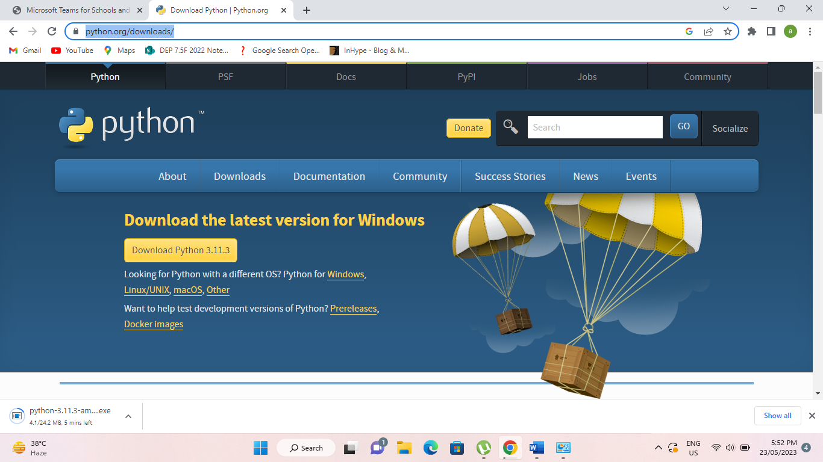

During the installation make sure to tick the Add python.exe to PATH and click install now.

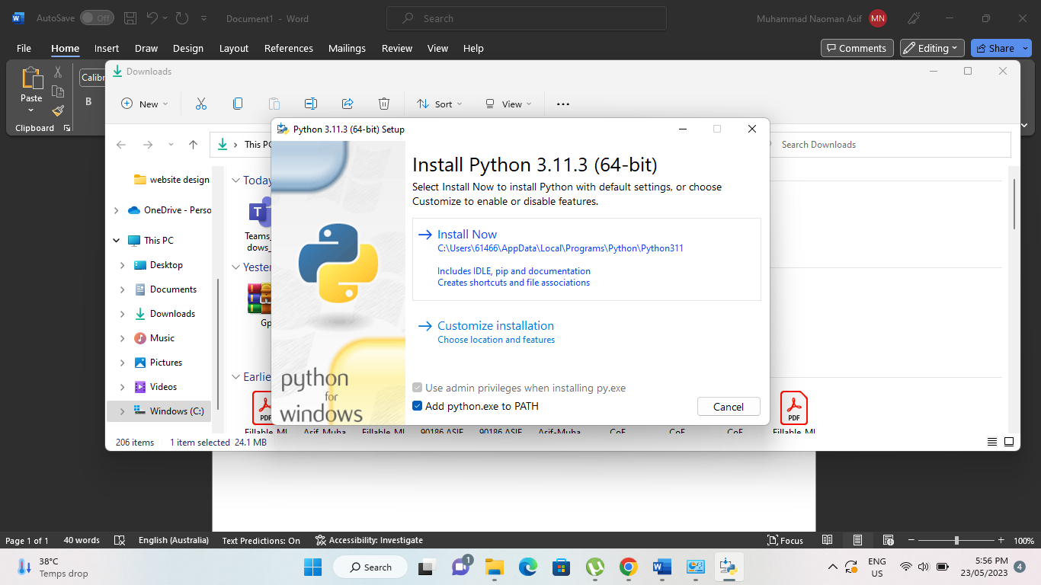

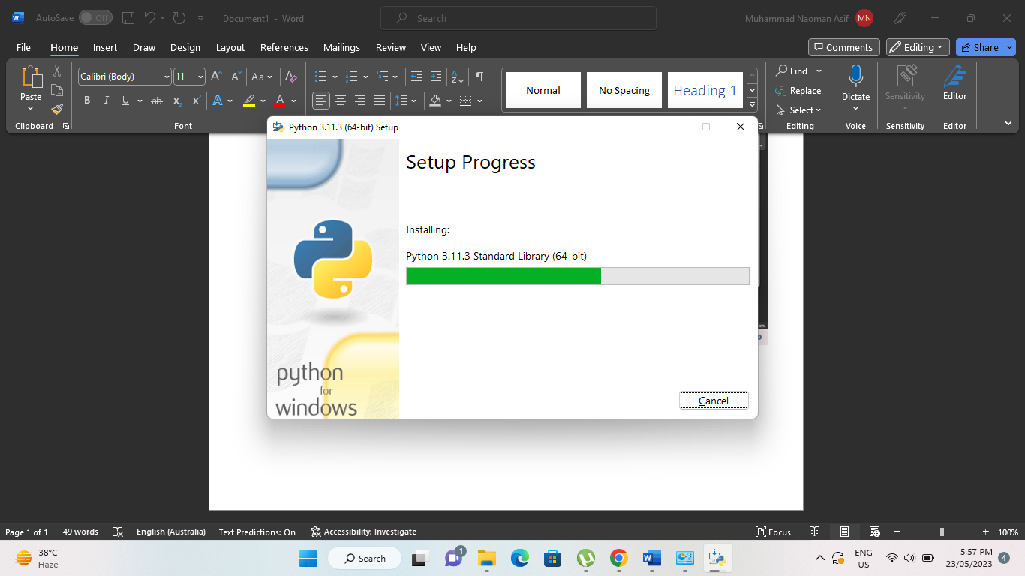

After installation is complete, to check if it was installed correctly, open the window command and type the command “python” and you should see the python version installed

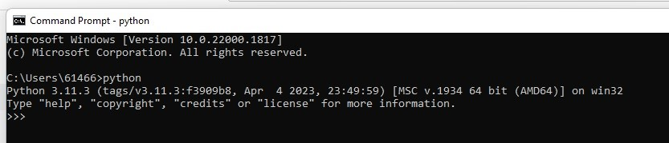

The next step is to install the visual Studio code (IDE) can be installed other like Pycharm. Follow the link <https://code.visualstudio.com/>  to download and install the visual Studio code from the website.

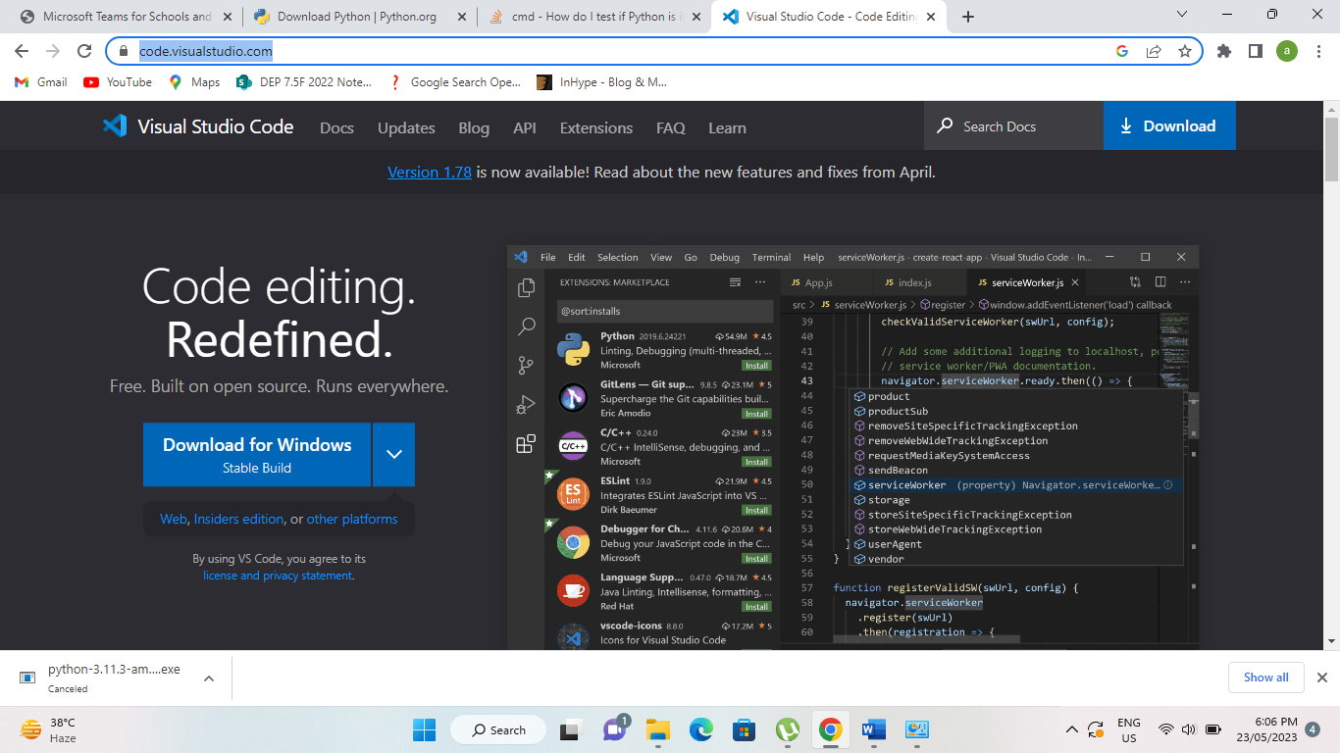

During the installation tick all the setiing as shown below

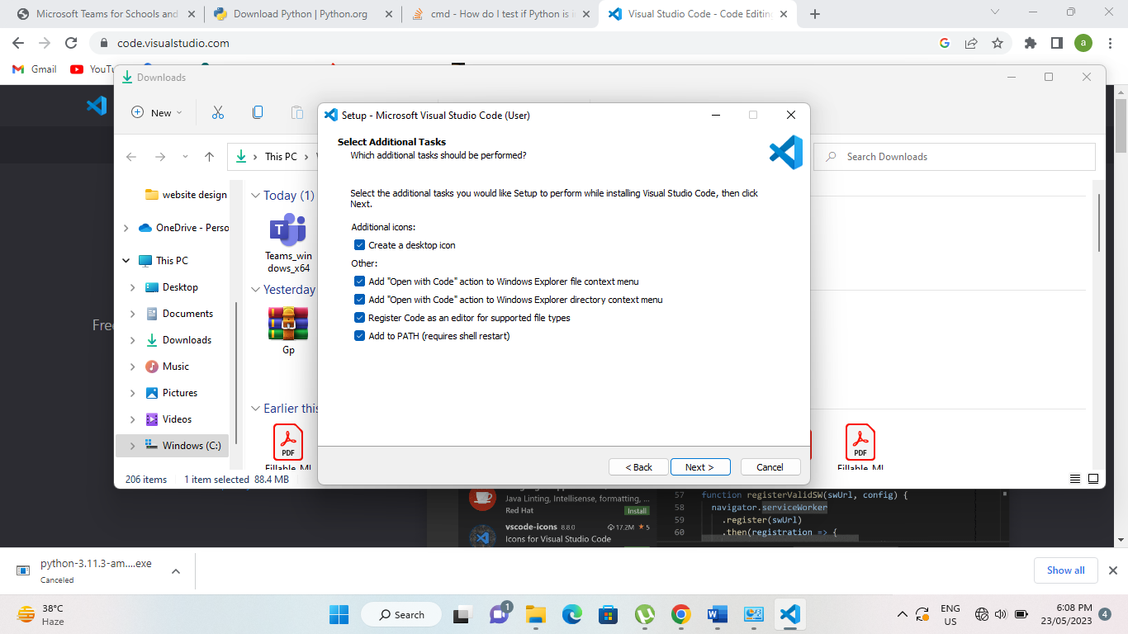

After installation open the visual studio code and open folder of the project files.

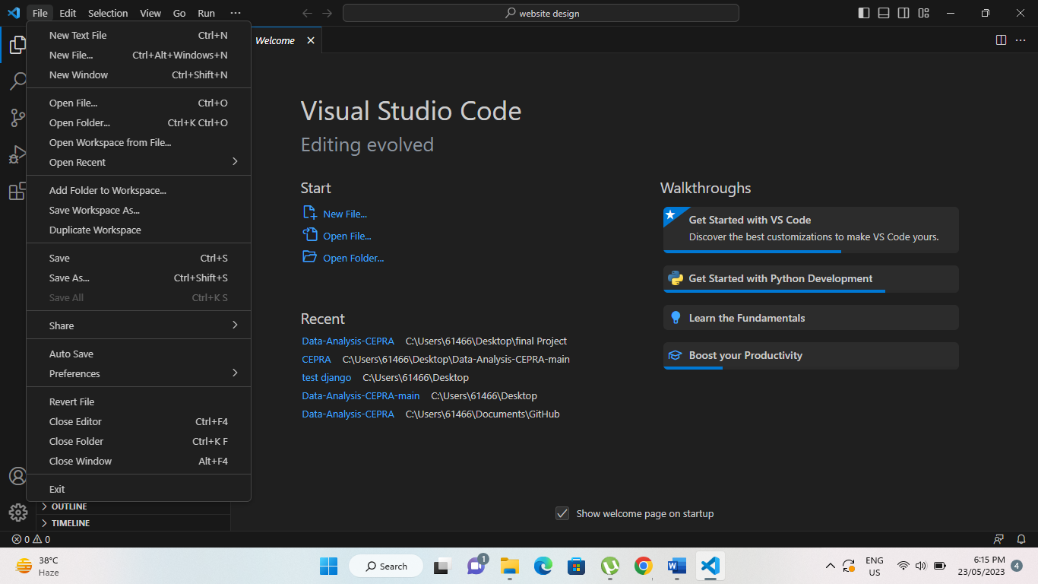

With Visual Studio Code installed, download the Solution zip file and extract to a folder of your preference.

On Visual Studio Code, click on open folder select the folder where you extracted to solution file and click on open

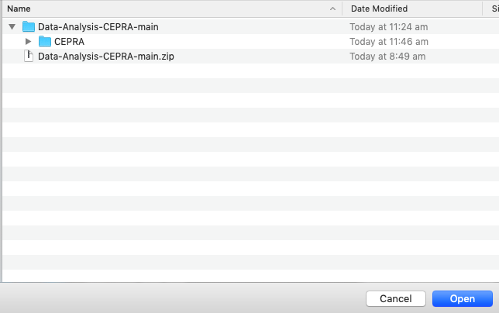

After loading, click trust the author to enable the project to run.

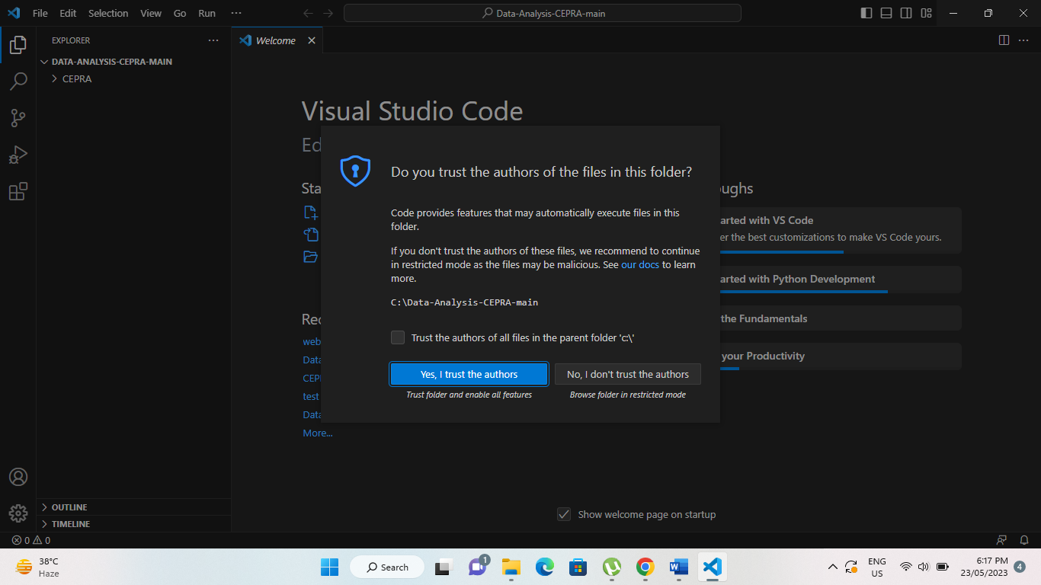

After opening the project folder, you will see all files on the left hand side.

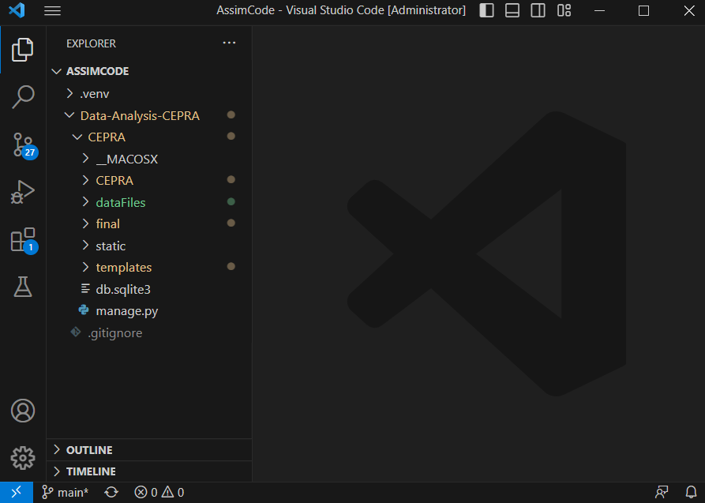

Double click to open requirements.txt and click on the blue square on the bottom right of the screen to create the virtual environment and install the dependencies -> select Venv (the installation may take a couple of minutes to complete.

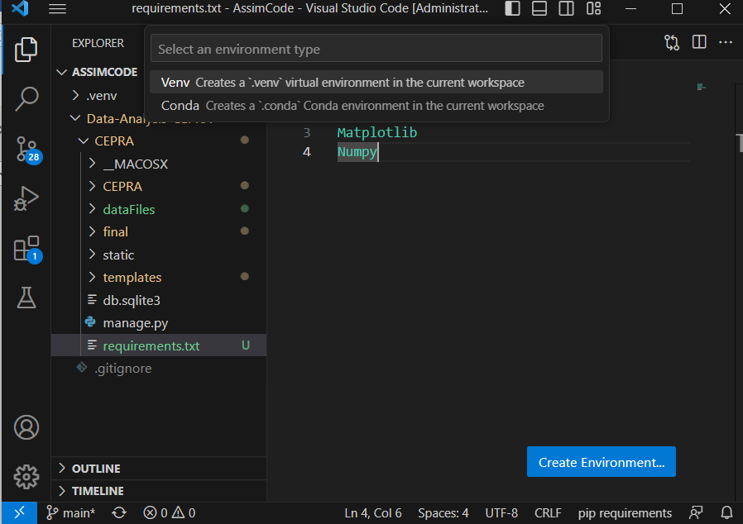

Now right click on the manage.py file and select open integrated terminal here.

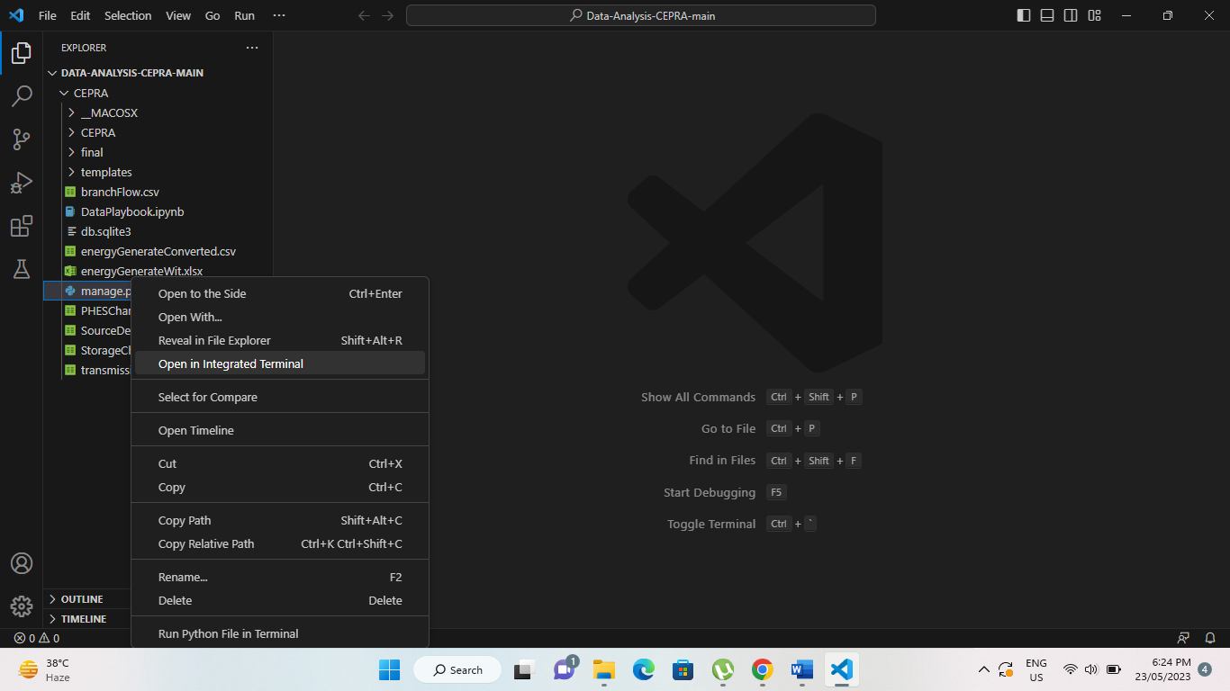

After that a terminal window will open at the bottom.

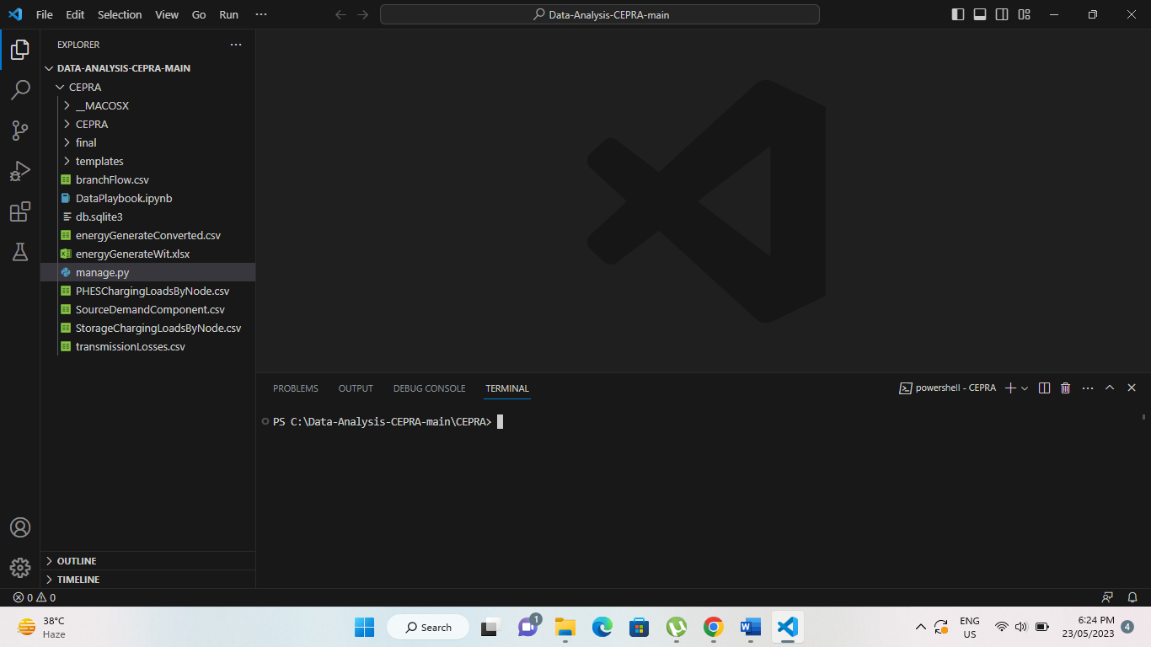

Now write the following command to run the server “python manage.py runserver”.

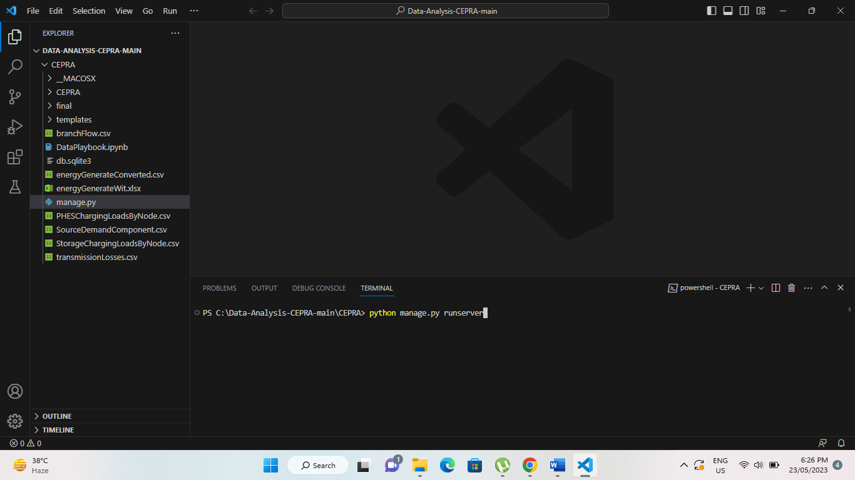

And you will be able to see the server is running.

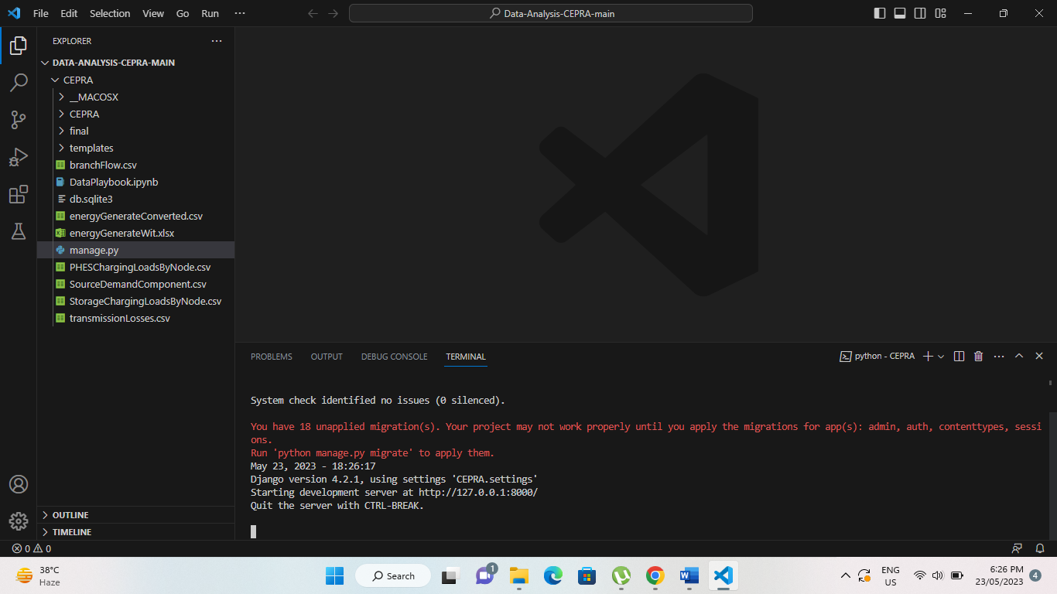

Now visit the development server link in any browser (chrome, edge, etc) displayed at the screen: (usually http://127.0.0.1:8000/) Sometimes can be a bit different if the port is already in use.

# User Interface Overview:

A detailed explanation of the user interface elements, menus, and navigation options within the Energy Balance software.

When first navigating to the page on localhost:8000 click on Energy Balance on the top

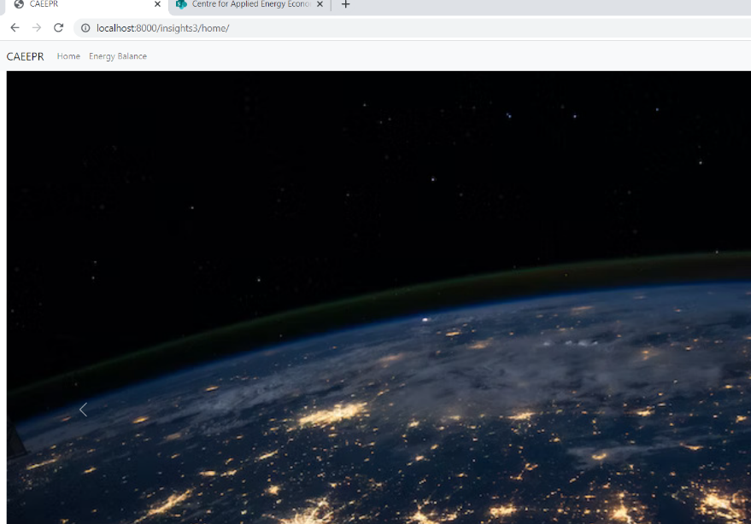

On the Energy Balance Page, select the first day of the data you are using (ie.: if FY 2030 select 1st July 2029)

Then Select The period you want to generate the graph and if you want to use any filter (Summer Weekend, Summer Weekdays, Winter Weekend or Winter Weekdays):

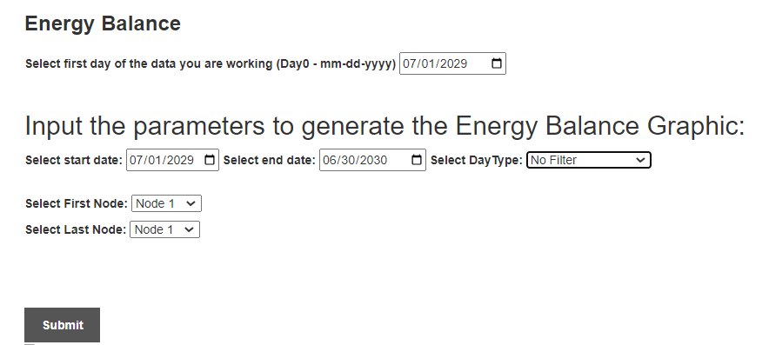

Then Select The nodes you want to look at (The system automatically identifies the State of Queensland if you select from node 1 to node 11 (All Queensland Nodes).

Then Click Submit to generate the graph:

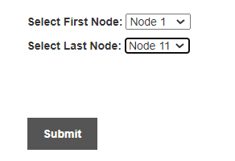

After a moment the Energy Balance Graphic will be generated and displayed below:

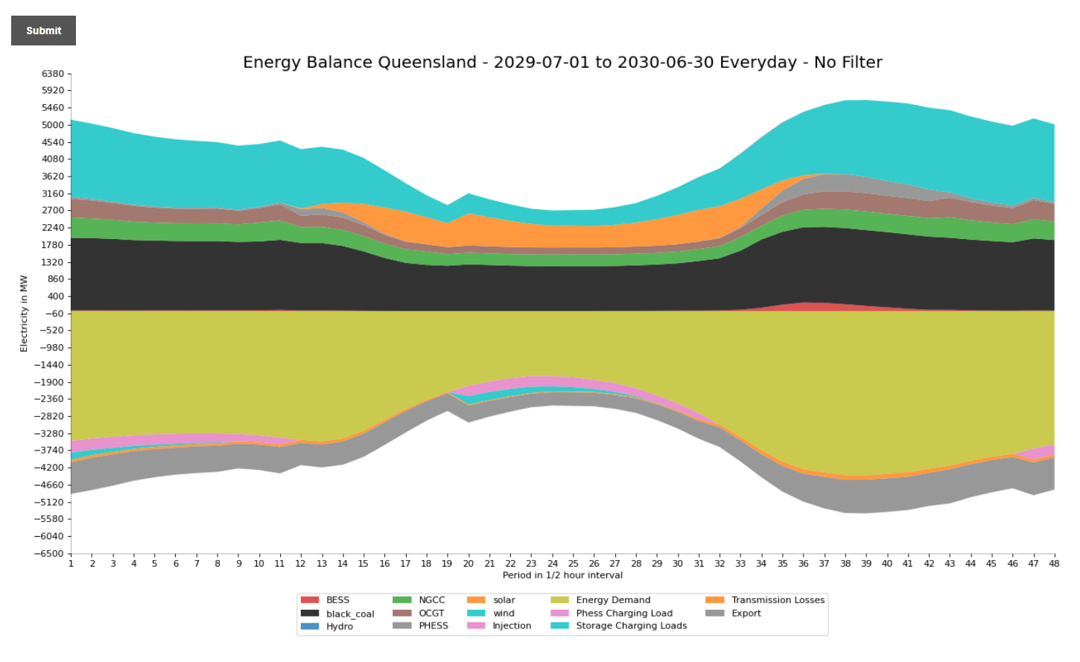

To Save the graph as an image, right click and select save image as.

# Pre-Loaded Data and how to replace/update data

The Solution comes with pre-loaded data from run 3, to generate graphics from data from another runs, simple copy and replace all the required .out files to the dataFiles folder inside the application folder from the ones of the run you require.

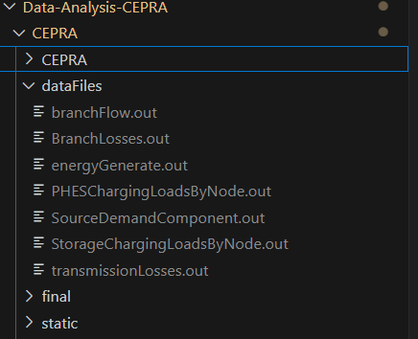

# Troubleshooting:

Common issues and solutions related to the Energy Balance software, providing assistance for resolving technical problems.

Make sure to follow all the steps in the installation and that the virtual environment is active.

Ensure the selected dates are contained in the data files you are working with (If you have data from one year starting in 01/07/2029 make sure you select the end date as 30/06/2030.

If changes in the Nodes or Generator type occur (ie.: technology type) please update the respective Mapping section of the views.py file (Lines 15 to 51).

# Frequently Asked Questions:

Answers to frequently asked questions regarding Energy Balance and its functionalities, troubleshooting, and best practices.